GDP, Unemployment
Student’s Name
Institutional Affiliation

Name of Country: Australia
Indicator 1: GDP
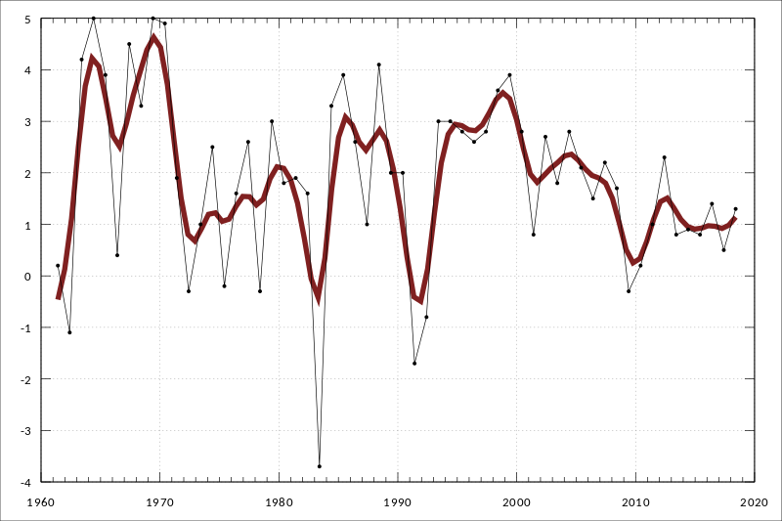
The economy of Australia is a mixed-market economy that has a GDP of A$1.69 trillion in the year 2017. Australia forth came as the country with the most considerable median wealth per adult in the year 2018. In 2016 the total wealth was AUD$8.9 trillion. During this year, Australia became the 14th biggest national economy by nominal GDP and was the 25th largest exporter of goods. Australia recorded the longest run of GDP growth in the developed world of 2017 fiscal quarter and marked twenty-six years since the country had a technical withdrawal. The service sector governs the economy of Australia.

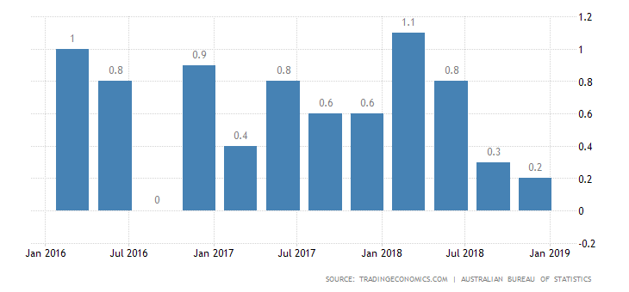
The GDP in Australia improved in 2018 December after growth of about 2.7% in the previous quarter. The Australian Bureau of statistics gives real GDP in the local currency connected 2016-2017 prices. In the recent reports, Nominal GDP reached 345.6USD in December 2018.

Indicator 2: Unemployment

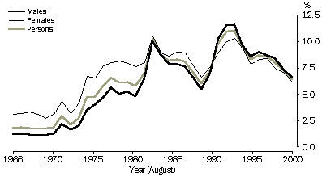

Between 1966 and 2000, the number of unemployed people in Australia has increased. During this period the number of people who are unemployed in Australia increased from 90300 to 596000. The unemployment rate has declined with the economic cycle. The unemployment rate has become higher with the downturn in the years; 1972, 1978, 1983 and 1993.
There are several problems caused by unemployment in Australia. Some of these problems may include severe financial hardship and poverty, homelessness and housing problems, family breakdown, shame and stigma among others.

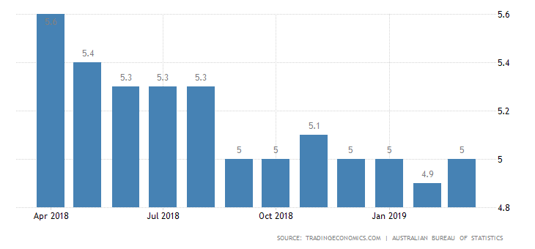

The different unemployment rate increased to 5% in March 2019. The price of participation raised to 65.7%. The underemployment rate became steady at 8.2%, and the employment-population ratio remained stable at 62.4%.
References
https://data.worldbank.org/
https://data.oecd.org/

